Experiment No. 1
SE (CSE) ROLL NO : 10937
Date of Implementation:29-01-2026
Aim: Perform Exploratory data analysis on real world data set
Programming Language Used : Python
Upon completion of this experiment, students will be able to CO1 : Execute exploratory data analysis on any structured data.
CO2 : Apply various analysis and visualization techniques using modern tools on real-world data
 | Indicator |  | Poor |  | Average | Good
 | Timeline  Maintains submission deadline (2) |  | Submission not done (0) |  | One or More than One week late (1) | Maintains deadline (2)
 | Completion and Organization (2) |  | Many mistakes in documents (0) |  | Document is just acceptable (1) | Completed whole document and neatly organized (2)
 | Program Performance (2) |  | Could not perform at all (0) |  | Implemented few parts (1) | Full implementation (2)
 | Knowledge  In depth knowledge of the Experiment (4) |  | Unable to answer questions(0) |  | Unable to answer few questions (1-2) | Able to answer all questions with proper explanation (3-4)
Assessment Marks :
 | Timeline
 | Completion and Organization
 | Program Performance
 | Knowledge
TOTAL :

EXPERIMENT | 1
Aim | Perform Exploratory data analysis on real world data set
Theory | Data analytics is the process of exploring and analyzing large datasets to make predictions and boost data-driven decision making. Data analytics allows us to collect, clean, and transform data to derive meaningful insights. It helps to answer questions, test hypotheses, or disprove theories. Data analytics is used in most sectors of businesses.  - Data analytics is used in the banking and e-commerce industries to detect fraudulent transactions.  - The healthcare sector uses data analytics to improve patient health by detecting diseases before they happen. It is commonly used for cancer detection.  - Data analytics finds its usage in inventory management to keep track of different items.  - Logistics companies use data analytics to ensure faster delivery of products by optimizing vehicle routes.  - Marketing professionals use analytics to reach out to the right customers and perform targeted marketing to increase ROI.  - Data analytics can be used for city planning, to build smart cities.  Types of Data Analytics Descriptive Analytics  It tells you what has happened. It can be done using an exploratory data analysis. Example: Studying the total units of chairs sold and the profit that was made in the past.  Predictive Analytics  It tells you what will happen. It can be achieved by building predictive models. Example: Predicting the total units of chairs that would sell and the profit we can expect in the future.  Prescriptive Analytics  It tells you how to make something happen. It can be done by deriving key insights and hidden patterns from the data. Example: Finding ways to improve sales and profit of chairs.  Python Libraries for Data Analytics  NumPy: NumPy supports n-dimensional arrays and provides numerical computing tools. It is useful for Linear algebra and Fourier transform.  Pandas: Pandas provides functions to handle missing data, perform mathematical operations, and manipulate the data.  Matplotlib: Matplotlib library is commonly used for plotting data points and creating interactive visualizations of the data.

 | SciPy: SciPy library is used for scientific computing. It contains modules for optimization, linear algebra, integration, interpolation, special functions, signal and image processing.
Implementati on | - Load any data set that is available in Python such as IRIS data set, TITANIC data set or TIPS data set  - Perform any two univariate non graphical techniques  - Perform any two univariate graphical techniques  - Perform any two multivariate non graphical techniques  - Perform any two multivariate non graphical techniques
Conclusion | Comment on the techniques you have used
Post Lab Questions: | - Differentiate between univariate and multivariate EDA.  - What is skewness and Kurtosis?

Implementation:

- Load any data set that is available in Python such as IRIS data set, TITANIC data set or TIPS data set
Soln.
Dataset used: TIPS Data Set: https://www.kaggle.com/datasets/jsphyg/tipping
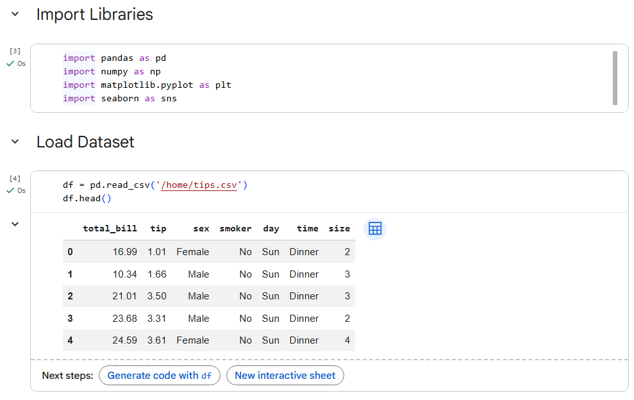

- Perform any two univariate non graphical techniques
Soln.
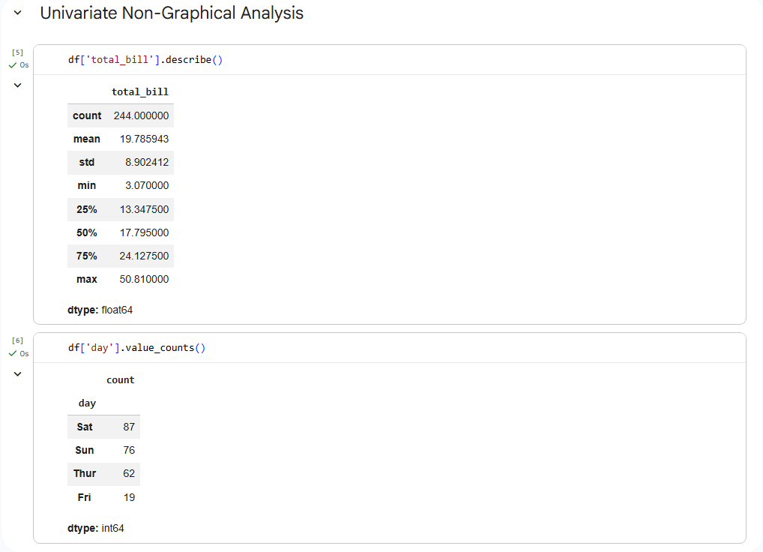

- Perform any two univariate graphical techniques
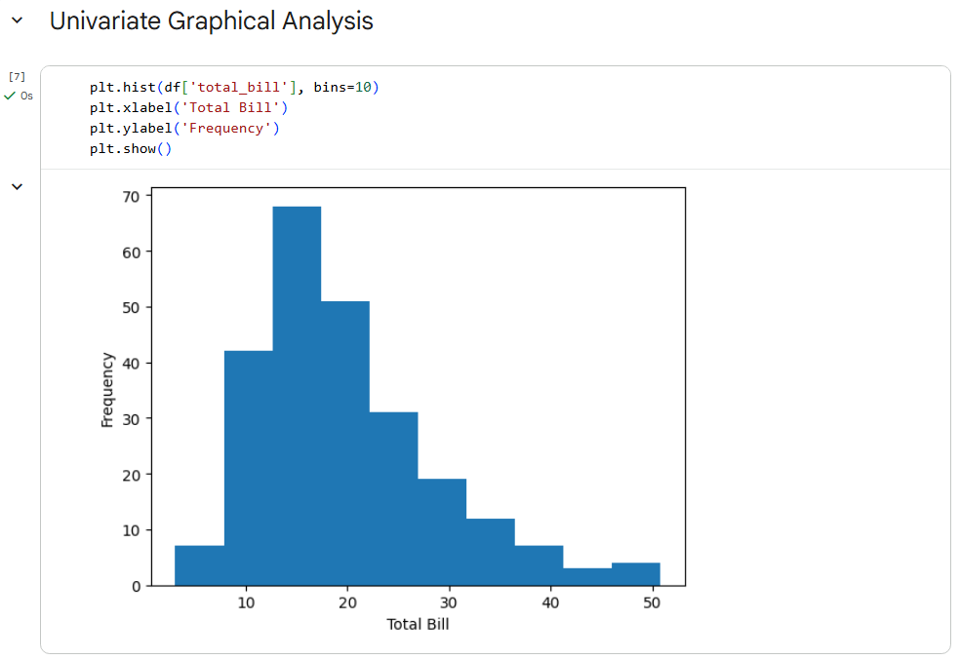
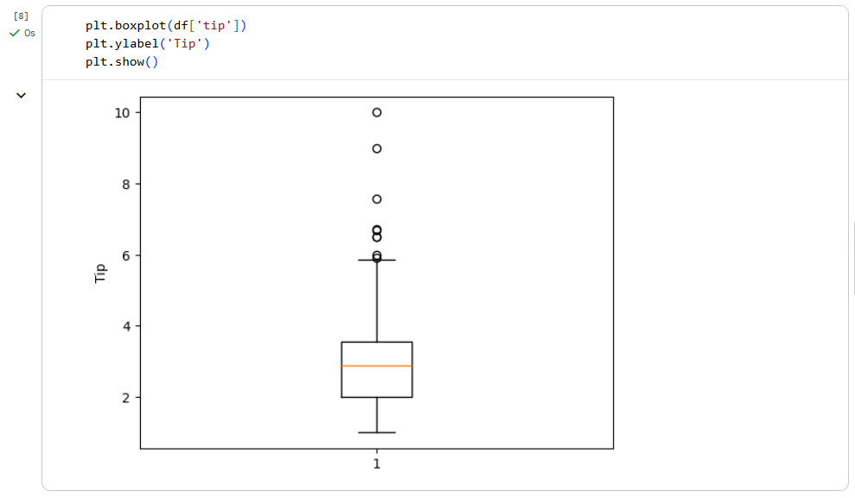

- Perform any two multivariate non graphical techniques

Soln.
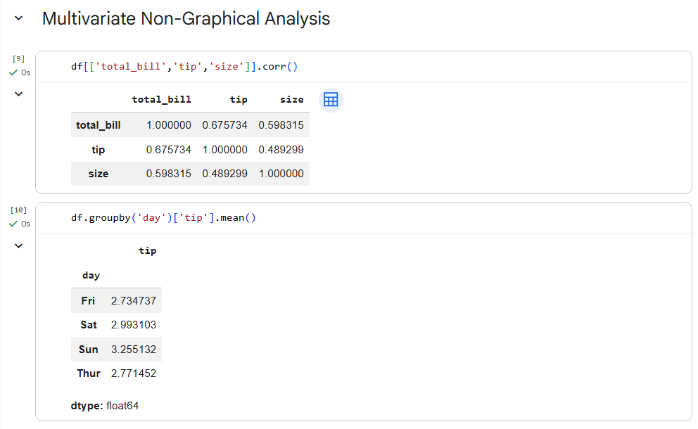

- Perform any two multivariate non graphical techniques

Soln.
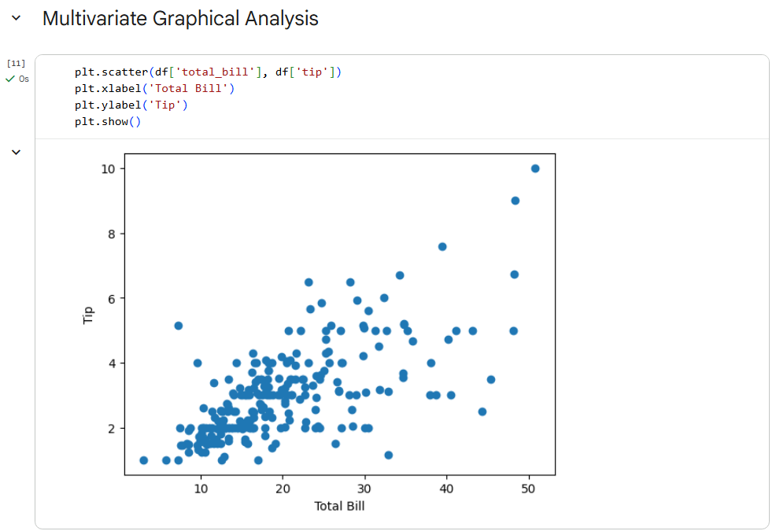
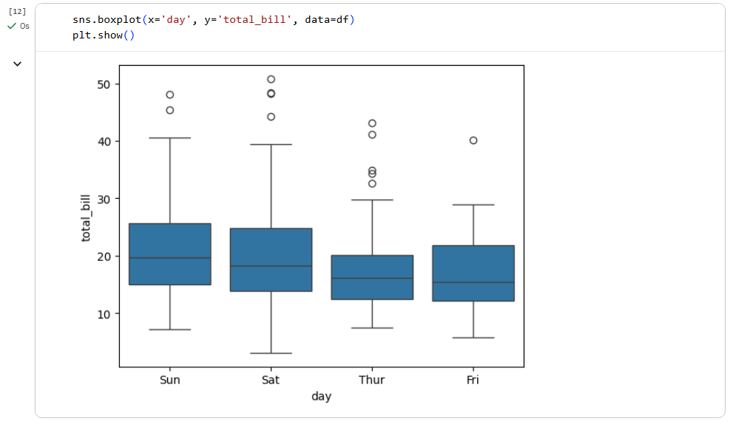

Conclusion: The exploratory data analysis techniques used helped in understanding the data by identifying patterns, trends, and relationships. These methods made the dataset easier to interpret and showed how data analytics supports clear and informed decision-making.

Post Lab Questions:

- Differentiate between univariate and multivariate EDA.
Soln.
Aspect | Univariate EDA | Multivariate EDA
Number of variables | One variable | Two or more variables
Main focus | Distribution and pattern of a single variable | Relationships between variables
Common techniques | Mean, median, variance, histogram, box plot | Correlation, scatter plots, covariance, pair plots
Goal | Understand individual variable behavior | Understand interactions and dependencies

- What is skewness and Kurtosis?
Soln.
Measures the asymmetry of a data distribution.
- Positive skew: long tail on the right
- Negative skew: long tail on the left

Measures the peakedness or tail heaviness of a distribution.
- High kurtosis: heavy tails, sharp peak
- Low kurtosis: light tails, flatter shape

